**• Introduction**

**o Can you explain the TCP/IP stack?**

TCP/IP stack:

application: supporting network applications

FTP, SMTP, HTTP

transport: process-process data transfer

TCP, UDP

network: routing of datagrams from source to destination

IP, routing protocols

link: data transfer between neighboring network elements

Ethernet, 802.111 (WiFi), PPP

physical: bits “on the wire”

**o Can you compare the packet switching and circuit switching networks with a**

**number of users?**

**packet-switching:** hosts break application-layer messages into packets

forward packets from one router to the next, across links on path from source to destination

each packet transmitted at full link capacity

**packet switching queuing and loss:**

if arrival rate (in bits) to link exceeds transmission rate of link for a period of time:

packets will queue, wait to be transmitted on link

packets can be dropped (lost) if memory (buffer) fills up

**circuit switching:**

end-end resources allocated to, reserved for “call” between source & dest:

* in diagram, each link has four circuits.
  + call gets 2nd circuit in top link and 1st circuit in right link.
* dedicated resources: no sharing
  + circuit-like (guaranteed) performance
* circuit segment idle if not used by call *(no sharing)*
* commonly used in traditional telephone networks

*packet switching allows more users to use network!*

example:

* 1 Mb/s link
* each user:
  + 100 kb/s when “active”
  + active 10% of time
  + *circuit-switching:*
  + 10 users
* *packet switching:*
  + with 35 users, probability > 10 active at same time is less than .0004 *

**o Can you calculate various delays?**

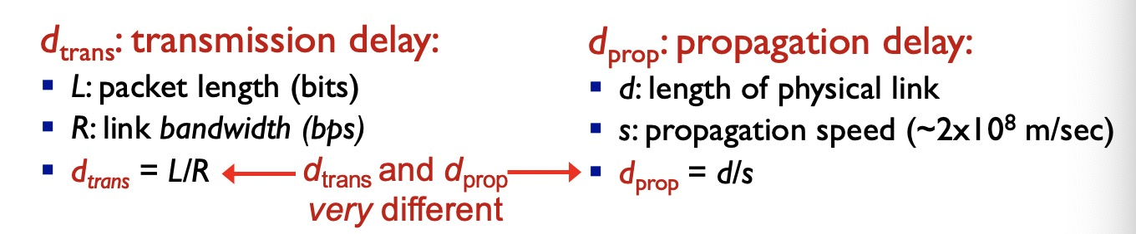

**Application layer**

loss-tolerant 容错

P2P architecture

▪ no always-on server

▪ arbitrary end systems directly communicate

▪ peers request service from other peers, provide servicein return to other peers

• self scalability – new peers bring new service capacity, as well as new service demands

▪ peers are intermittently connected and change IP addresses • complex management

Sockets

▪ process sends/receives messages to/from its socket

▪ socket analogous to door

• sending process shoves message out door

• sending process relies on transport infrastructure on

other side of door to deliver message to socket at

receiving process

**o Can you find and explain detailed information on a given application message**

**(e.g., HTTP request/ response, DNS request/response, DHCP)?**

200 OK

• request succeeded, requested object later in this msg

301 Moved Permanently

• requested object moved, new location specified later in this msg

(Location:)

400 Bad Request

• request msg not understood by server

404 Not Found

• requested document not found on this server

505 HTTP Version Not Supported

Cookies

Web caches

**DNS: domain name system 把网址转换成ip address 的系统**

**o Can you explain the request and response of application messages?**

**• Transport layer**

**o Can you explain the differences between UDP and TCP?**

**UDP:**

**TCP:**

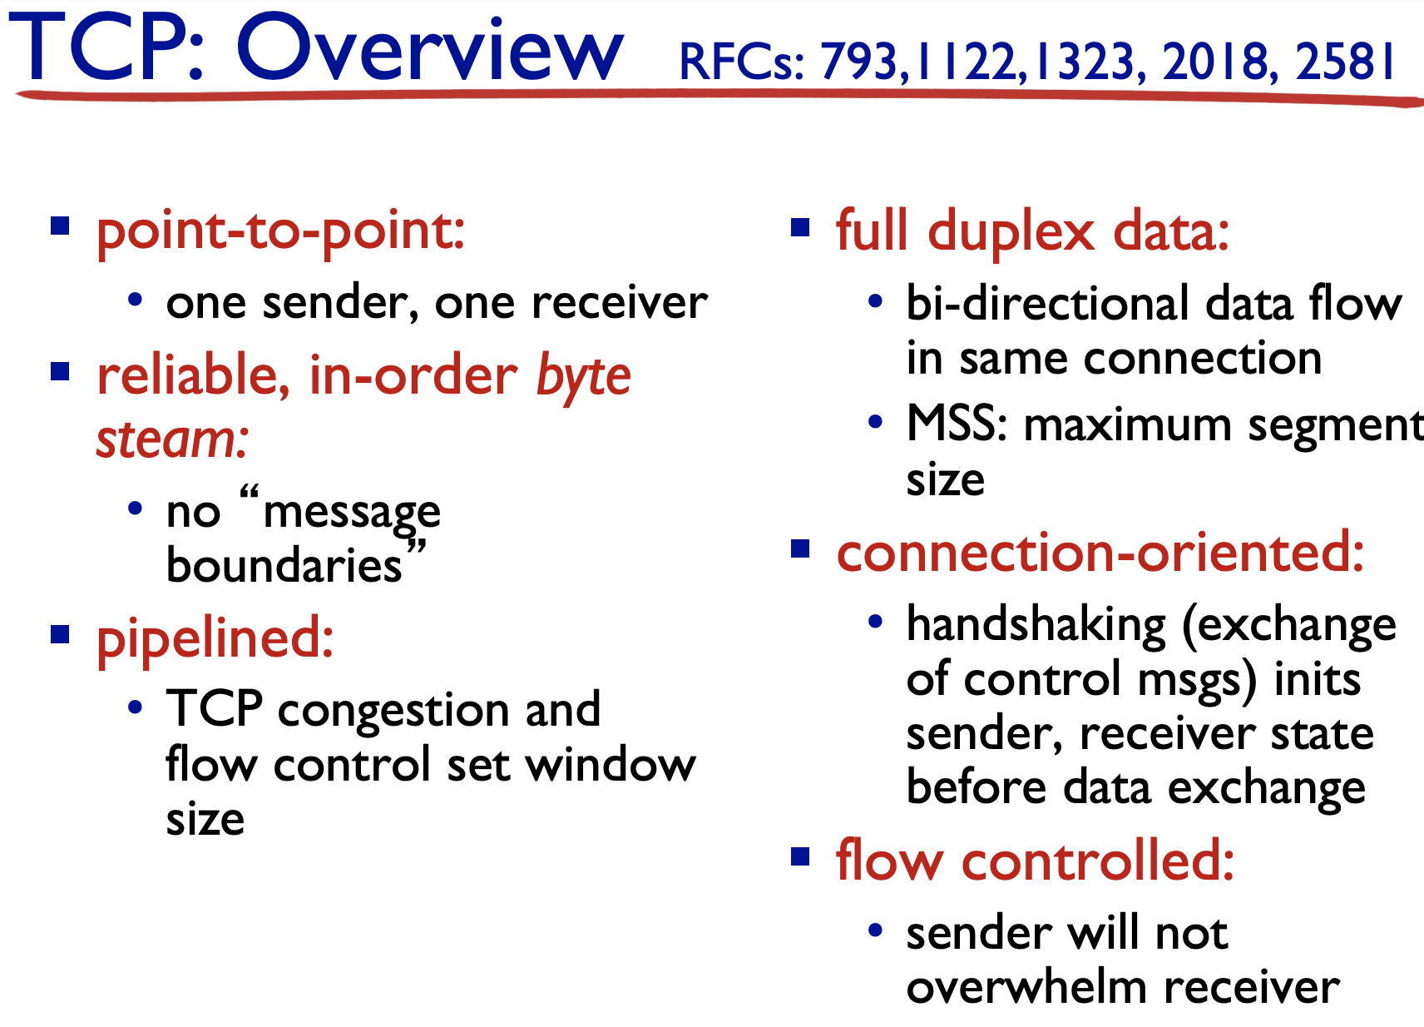

**o Can you explain how to guarantee reliable delivery of application messages?**

rdt: reliable data transfer

UDP rdt:

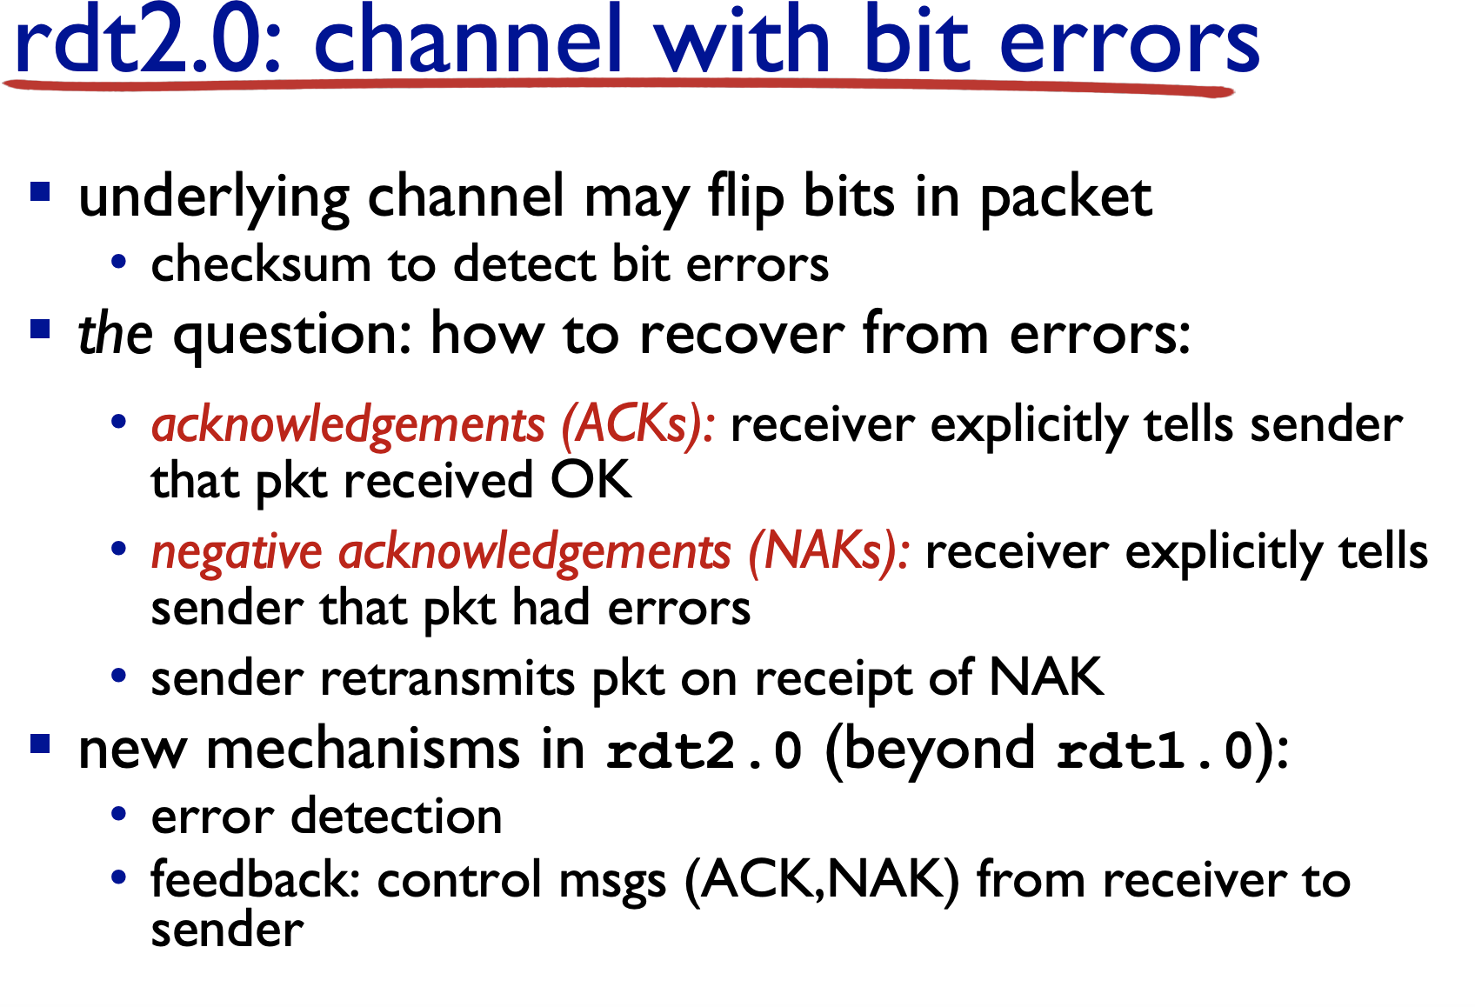

**TCP rdt:**

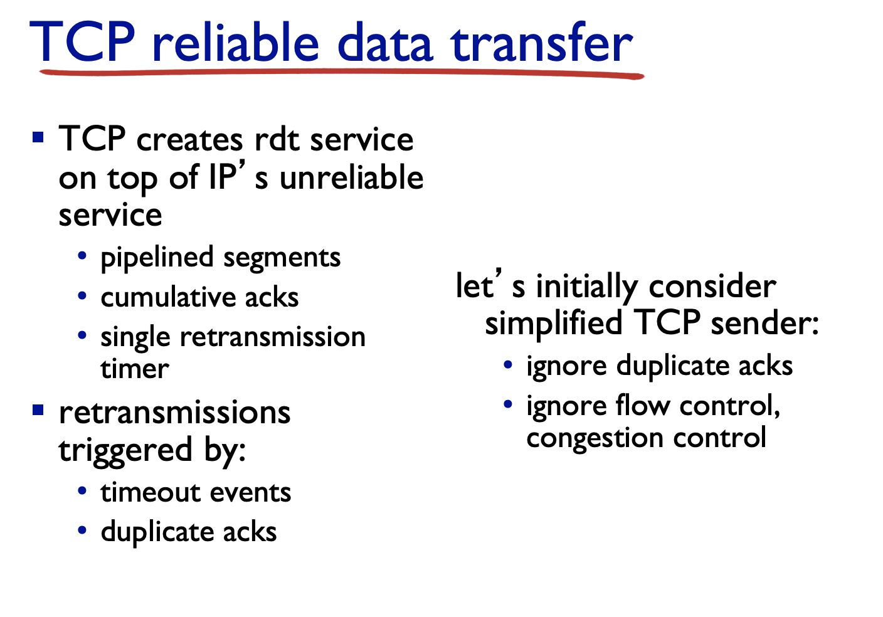

**o Can you find information (port number, direction, application protocol etc)**

**given transport layer protocol header (TCP or UDP) dump?**

**o Can you calculate checksum and verify it?**

**先相加，加到最后如果要进一把1移到最后，如果没有就不变，最后reverse。**

**o Can you explain the differences between flow control and congestion control?**

**Flow control:**

receiver “advertises” free buffer space by including rwnd value in TCP header of receiver-to-sender segments

• RcvBuffer size set via socket options (typical default is 4096 bytes)

• many operating systems autoadjust RcvBuffer

▪ sender limits amount of unacked (“in-flight”) data to receiver’ s rwnd value

▪ guarantees receive buffer will not overflow

**Congestion control:**

congestion:

informally: “too many sources sending too much data too fast for network to handle”

different from flow control!

manifestations:

lost packets (buffer overflow at routers)

long delays (queueing in router buffers)

a top-10 problem!

**• Network layer**

**o Can you explain the packet scheduling in a router?**

scheduling: choose next packet to send on link

▪ FIFO (first in first out) scheduling: send in order of arrival to queue

• real-world example?

• discard policy: if packet arrives to full queue: who to discard?

• tail drop: drop arriving packet

• priority: drop/remove on priority basis

• random: drop/remove randomly

**o Can you explain the packet fragmentation and how it works?**

1. network links have MTU (max.transfer size) - largest possible link-level frame

• different link types, different MTUs

1. large IP datagram divided (“fragmented”) within net

• one datagram becomes several datagrams

• “reassembled” only at final destination

• IP header bits used to identify, order related fragments

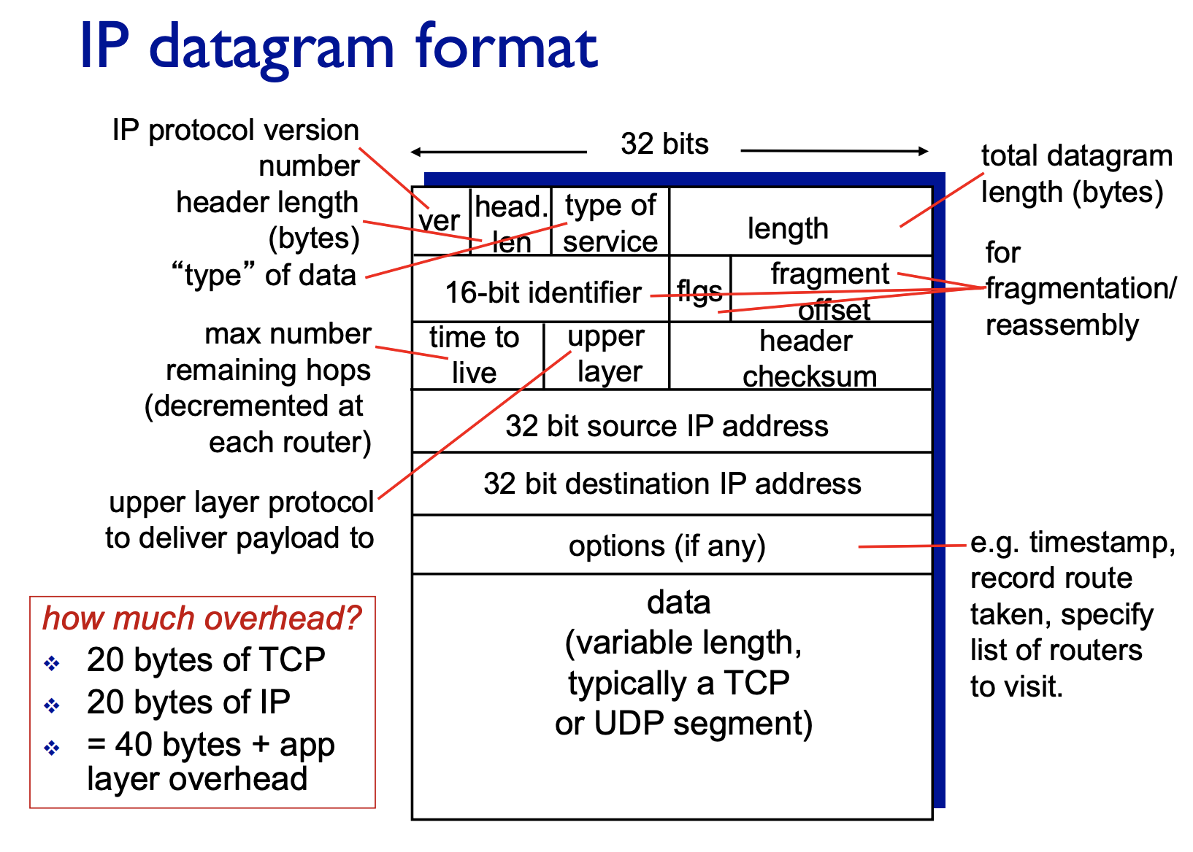

**o Can you explain the differences between the operation of distance vector and**

**link state routing algorithms?**

**o Given a network graph, can you make a table that contain the minimum-cost**

**routes from a source node to all other nodes using Dijkstra’s algorithm and**

**Distance Vector algorithm (Bellman-Ford algorithm), respectively?**

**o Can you explain NAT?**

**o Can you explain the difference between IPv4 and IPv6?**

1. no fragmentation/reassembly allowed at intermediate routers:

• These operations can be performed only the source and destination.

▪ ICMPv6:

• new version of ICMP

• additional message types, e.g. “Packet Too Big”

• multicast group management functions

1. Header checksum:

• removed entirely to reduce processing time at each hop

• Since the IPv4 header contains a TTL field, the IPv4 header checksum needed to be recomputed at every router; a costly operation

1. options:

• No longer a part of the standard IP header.

• cf. IPv4 option: used for network testing, debugging, security, and more. This field is usually empty.

**CIDR: Classless InterDomain Routing**

**• subnet portion of address of arbitrary length**

**• address format: a.b.c.d/x, where x is # bits in subnet portion of address**

**• Link layer**

**o Can you explain how odd/even parity bit works? Can you find parity bit given**

**binary digits? Can you explain the 2-D parity and its limitation?**

**o Can you calculate/show how CRC is used to detect error(s)?**

**o Can you explain why forward error correction (FEC) is used? Can you show**

**how FEC is used to detect and/or correct error(s)?**

**o Can you explain MAC address? Can you find relevant information given**

**MAC address?**

**o Can you explain how MAC addresses/IP addresses are used in a LAN and**

**between different LANs?**

**o Can you explain the MAC protocols and their differences (e.g., CSMA)?**

**o Can you explain how VLAN is working?**

**o Can you explain how MPLS is working?**